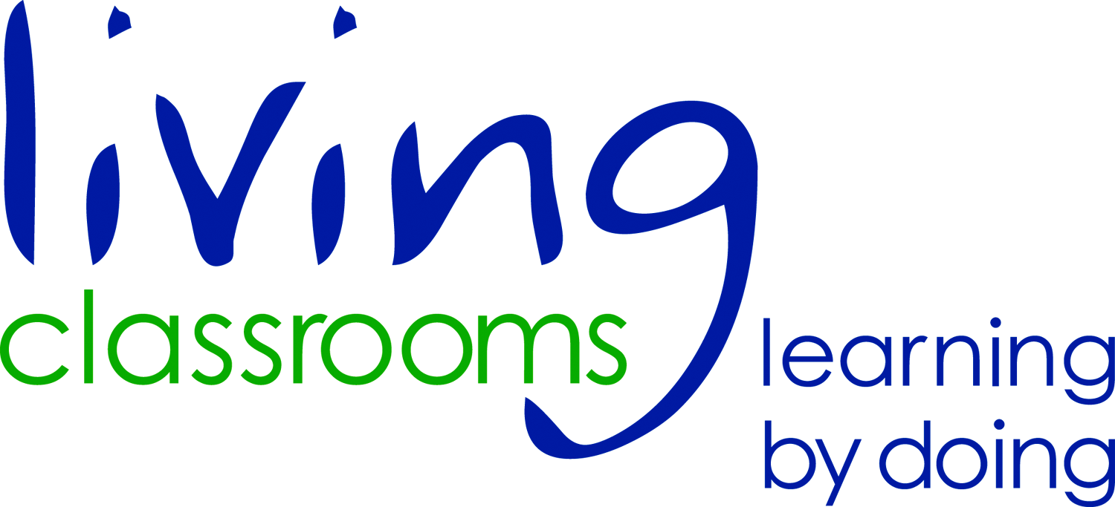
LIVING CLASSROOMS FOUNDATION, INC.

ADULT WAIVER (all adults attending the program must complete this form)

I, , agree to take part in an educational expedition sponsored by the Living Classrooms Foundation, Inc. Living Classrooms Foundation assumes responsibility and liability for property damage and injuries due to its negligence, and the school system/organization assumes liability for property damage and injuries due to its negligence. I acknowledge that the Living Classrooms Foundation reserves the right to video, photograph, record any activity or place on the Internet any pictures (without the name of the participant) associated with this educational trip.

Signature Date

Date of Trip Address

Group/School Phone #

To help us provide the safest trip possible, please provide some basic health information:

Health Problem/Concerns or any allergies: (illnesses, surgeries, asthma, heart condition, seizures, etc…)

Do you carry an Epi-pen? Yes No Do you carry an inhaler? Yes No

All medications you currently take:

Emergency contact (name and phone number):

Your role: We thank you for your help in keeping students on task, safe and respectful of the educators and other students. Since we pride ourselves in keeping all our stations “hands on”, with as much student interaction as possible, we ask that all teachers and chaperones refrain from answering the educator’s questions or doing the activity for the students. We appreciate your help, as you are a valuable component for a great day!
What to Wear: Be comfortable! You will need closed toed shoes. In bad weather, be sure to wear rain gear; no umbrellas allowed. During the colder times of year, we recommend that participants wear gloves, hats and layers of synthetic materials and wool. It is better to have too many layers than not enough. During the warmer seasons, please remember sunscreen, hats, sunglasses and a water bottle.
Lunch: Remember to bring a bag lunch and a drink. There is no place to buy a lunch during the day.
Please join us in striving for NO TRASH LUNCHES!! That means using a Tupperware type container rather than a plastic bag for your sandwich, a thermos for your drink, reusable lunch bags and cloth napkins.
Restrictions: Please leave your radios, tape/CD/MP3 players, video games, gum and candy at home. In addition, NO horseplay, NO smoking, NO alcohol and NO drugs are tolerated on Living Classrooms’ vessels. We ask that you turn your cell phone off during the trip; it is very distracting to the students and crew.
RESPECT: Above all else, students, teachers and all participants should show respect for each other, the educators and their environment. This will ensure a fun, safe and educational day for everyone. Living Classrooms Foundation reserves the right to remove any individual whose behavior may be deemed inappropriate or unsafe.

